**ECE361 – Computer Networks**

**Wireshark Lab 1: HTTP**

First Name: Bahareh Last Name: Farhadi

First Name: Jingfeng Last Name: Chen

1.

4: Source Port, Destination Port, Length, Checksum.

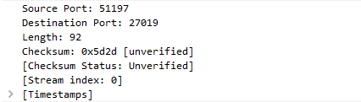

2.

8 bytes

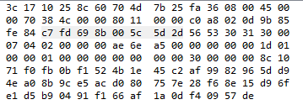

3.

It is the length from the UDP header (c7) to the end of the packet (de). (length of the data + length of the UDP header file)

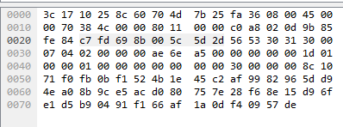

4.

2^16 (2 bytes length) - 8 (8 byte header) - 1 (start from 0) = 65527 bytes

5.

2^16 (2 bytes length) - 1 (start from 0) = 65535

6.

Protocol: UDP (17)

Decimal = 17

Hexadecimal = 0x11

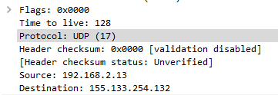

7.

TCP: source IP, destination, protocol

UDP: checksum, length

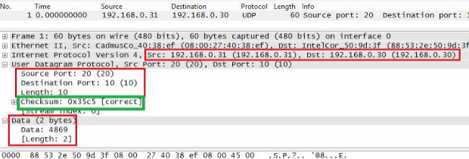

(from google)

8.

The destination port of the 2nd packet is determined by the source port of the 1st packet, whereas the source port of the 2nd packet is determined by the destination port of the 1st packet.